**Project Initialization and Planning Phase**

| Date | 15 July 2024 |
| --- | --- |
| Team ID | 740016 |
| Project Name | Revolutionizing Automotive Resale: AI-Driven Prediction of Used Toyota Corolla Car Prices |
| Maximum Marks | 3 Marks |

**Define Problem Statements (Car Price Problem Statement Template):**

The resale market for used Toyota Corolla cars is plagued by inconsistencies and inefficiencies in price determination, leading to potential financial losses for sellers and buyers alike. Traditional methods of valuation often fail to account for the myriads of factors that influence car prices, such as condition, mileage, location, and market trends, resulting in inaccurate and unfair pricing.

**Example:**

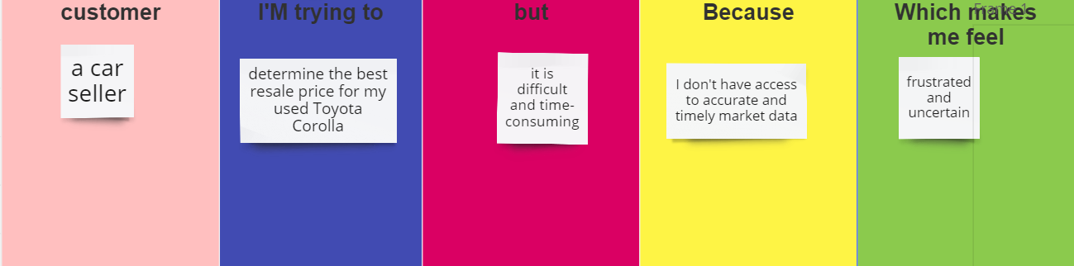

|  |  |  |  |  |  |
| --- | --- | --- | --- | --- | --- |
| **Problem**  **Statement (PS)** | **I am**  **(Customer)** | **I’m trying to** | **But** | **Because** | **Which makes me feel** |
| PS-1 | A car seller | Determine the best resale price for my used Toyota Corolla | It is difficult and time-consuming | I don’t have access to accurate and timely market data | Frustrated and uncertain |